**Introduction**

Images have become popular with users for communication. Users often send sensitive pics each other over the internet. However, the attackers can eavesdrop on their communication and see the images being transmitting. Encryption is the technique using which users can “hide” their original image. In Image encryption, users have to encrypt the image using a secret key and send the encrypted image or cipher image to the intended user. The receiver can then use the secret key to decrypt the image. This is possible due to image encryption and decryption.

In this report, we implement 2 papers: “A new 1D chaotic system for image encryption” by Yicong Zhou n , Long Bao, C.L. and Philip Chen which uses Logistic-tent map and “A novel bit-level image encryption algorithm based on chaotic maps” by Lu Xu, Zhi Li n , Jian Li, Wei Hua which uses PWLCM chaotic map.

**Chaos theory**

Chaos theory is a branch of mathematics that deals with non-linear dynamic systems. The systems are considered non-linear because of the multiple feedback between the components of the system. The systems are considered as dynamic because of the changes shown by it due to its current state. Such system often formed are known as chaotic maps. Chaotic map have high sensitivity to their initial values and control parameters, chaotic property, non-convergence, and state ergodicity.   
These properties have led the researcher to use chaotic map for encryption purposes.

In the image encryption scheme which uses chaotic maps, usually chaotic map are used to generate the keys or actual values using which the pixels or bits of the image is encrypted. The user can specify the initial conditions of the chaotic map which then generates the string or number of characters required to encrypt the full image. The other part of the scheme would deal with the encryption and decryption of the image just like any other encryption scheme. However, it is important to note that users have to keep the initial condition as a secret to ensure that the attacker doesn’t decrypt your encrypted images.

In this project, we used 2 chaotic maps: Piecewise linear chaotic map(PWLCM) and Logistic-Tent map.

Piecewise linear chaotic map (PWLCM)

Piecewise linear chaotic map is described by the following equations:

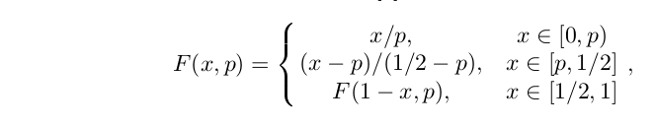

Where the value of p is the interval (0,0.5) and initial value of x should be in the interval (0,1). The users can specify the values of p and x which serves as the secret key. Using these initial values, required length of key stream can be calculated. PWLCM has a uniform invariant distribution and very good ergodicity, confusion, and determinacy, so it can provide excellent random sequence, which is suitable for information encryption.

Logistic-Tent Map

Logistic map is defined by the following equation:

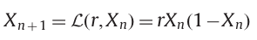 Where r is in the range of (0,4]

Tent map is defined by the following equation:

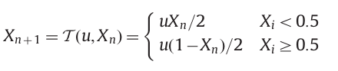

where u is in the range of (0,4]

Individually both the maps have mainly 2 problems: First, its chaotic range is limited only within [3.57,4]. Even within this range, there are some parameters which make the Logistic map to have no chaotic behaviours. This is verified by the blank zone in its bifurcation diagram. A positive value of Lyapunov Exponent means that the chaotic map has a good chaotic property. However, for r < 3.57, the exponent is less than zero. Second, the data range is smaller than [0,1] thus the values generated are not uniform and hence not really suitable for generating pseudo-random sequences.

Logistic-tent map is combination of 2 chaotic maps: Logistic and tent map. These maps are combined using the following equation:

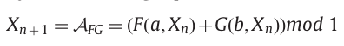

Substituting the function F and G for logistic and tent map questions, we get:

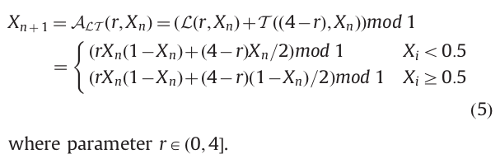

The benefit of combing 2 chaotic map has 3 advantages : 1) the range of this chaotic map Is more than its seed map. 2) The values are more uniformly distributed and 3) Lyapunov Exponents is higher than its seed maps. Thus we get a better chaotic map by combing these 2 chaotic maps.

**My contribution**

In this project, I focused on implementing the encryption scheme described in both the papers. I used matlab to write the code for implementing the encryption. While implementing the code for encryption, I had to understand how chaotic maps are used in the scheme and how to combine the work done by my teammate into my code. I had to modify the code for chaotic map so that I can use it in my encryption. Implementing the encryption was a bit of challenge as papers relied heavily upon mathematical equations to describe the scheme.

As a group leader, I had divided the work among my teammates. I helped them whenever they had faced my problem.

**Methodology**

Methodology of the paper:

*“A novel bit-level image encryption algorithm based on chaotic maps” by Lu Xu, Zhi Li n , Jian Li, Wei Hua*

Encryption Scheme:

1) Before we begin the encryption scheme, we need to create the bitstream to encrypt the image from the chaotic map: PWLCM. The user needs to specify to initial parameters (u0,x0) to generate the bit stream from the chaotic map. Once the bitstream is generated, then we need to make sure that values are between 0 and 255 so we use this equation:

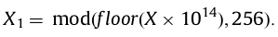

Let’s assume that the size of the image is M x N. Then we need to iterate (M x N + N0) number of values. We discard the initial N0 to avoid any bad values in the stream.

Once we have the values in integer, we decompose them into bitplanes. We need 8 bitplanes namely, b1,b2,b3,b4,b5,b6,b7 and b8. We need to combine these bitplanes into 2 groups as b1 and b2, putting higher bitplanes in one group and lower bitplanes in another.

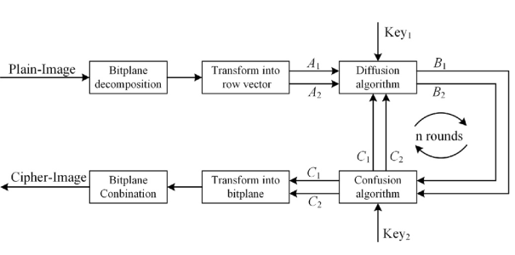

2) We read the image and decompose into bitplanes and form 2 groups A1 and A2.

Diffusion phase:

* Calculate the sum of elements in A2. Number of elements in A2 is L = 4MN.
* Cycle shift A2 by the sum to obtain A11.
* Encrypt the first element of A11 with last element of A11, first element of A2 and b1 using this equation:

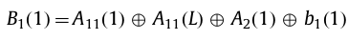

* Change the value of i =2 till L to encrypt the matrix A11 using following equation:

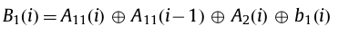

* Use the same method to encrypt the A2.
* Calculate the sum of elements in B2 and cycle shift right the matrix A2 to get A22
* Use the following equation to encrypt the first element of A22. 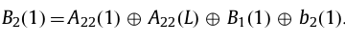
* Change the value of i=2 till L to encrypt A22 using the following equation:



Confusion Phase:

* Calculate the sum of elements of B1 and B2 to obtain the initial value to obtain bitstream from the chaotic map PWLCM:

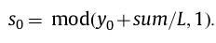

* Using the obtain 2 sequences Y and Z, using Y(i), we swap the values of B1(i) with B2(Y(i)) and we swap the values of B2(i) with B1(Z(i)) for all values of i from 1 to L
* Finally, combine the bitplanes back to the image which gives the cipher/encrypted image.

Decryption scheme

* Decryption process is the reverse of the encryption.
* Using the key to obtain the sequences Y and Z using which reverse-swap the values.
* In diffusion phase, one has to solve the equation using cross-multiplication method to obtain the original image.

Methodology of the paper:

*A new 1D chaotic system for image encryption by Yicong Zhou n , Long Bao, C.L and Philip Chen*

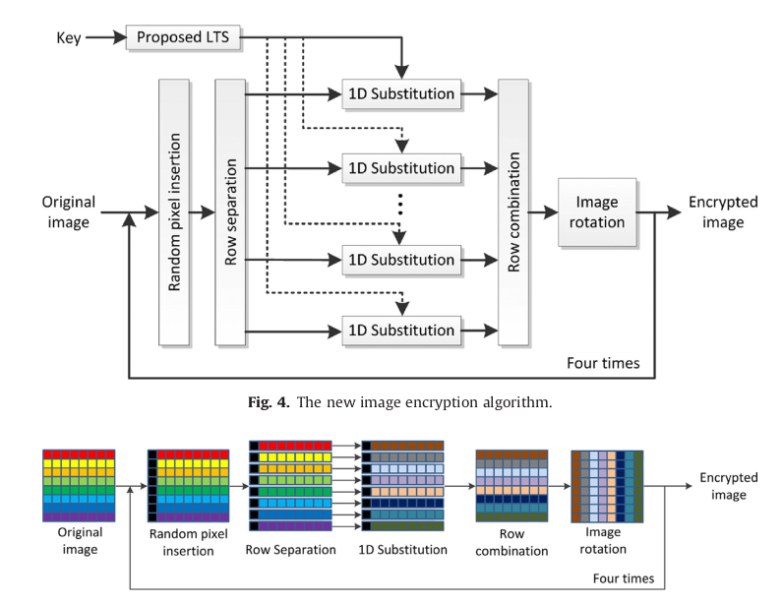

Encryption Scheme

1) The encryption uses 4 rounds to encrypt an image. After the end of every round, the image is rotated counter clockwise 90 degree.

2) In every round, a random pixel of column 1 and length equal to the number of rows of the image is added to it.

3) After adding, rows are separated and 1-D substitution occurs according to these equations:

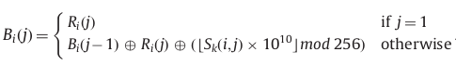

R is representing the row in the image. S is the row of values obtained by the following equation:

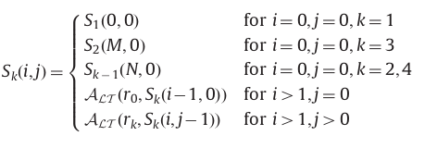

Alt is the logistic-tent map which is used to get the values for S row matrix. R0 and rk are the user defined values.

Depending the round number (k), S uses different values as the initial condition for Alt.

4) Once the substitution is done, the rows are combined and cipher image has been created.

Decryption scheme

* It is the reverse of the encryption scheme
* The substitution process uses this equation:

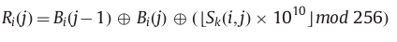

**Security analysis**

Key sensitivity

In key sensitivity, analysis is done to check if image can be decrypted when the attacker has all the key except one bit value changed. To do this analysis, key is taken and an image is encrypted. Then the value of the key or more specifically, one bit from the bitstream used to encrypt is changed and an image is encrypted again. Now, both the images are compared. Ideally, there should not be any match between these 2 images. If there is a high percentage of match between the images, then it has failed this analysis.

This same analysis is also done in the decryption process, where the one bit of the decryption key is changed and output images are compared to see if there is any match.

Differential attack

In this attack, an image is taken encrypted with a key. Then that image is changed by one bit and encrypted again with the same key. We calculate the NPCR and UACI score which are designed to test the number of changing pixels and the number of averaged changed intensity between ciphertext images. NPCR stands number of changing pixel rate and UACI stands for unified average changed intensity.

Histogram analysis

In the histogram analysis, we obtain the histogram of the image which gives the intensity of the image over a spectrum. We check the histogram of the encrypted image to ensure that it is uniform the spectrum to avoid the attacker decrypting the image

Entropy

Entropy value is calculated in order to how random the pixel values are in the image. A high entropy score of 7.9+ means the image is very random.

**Results**

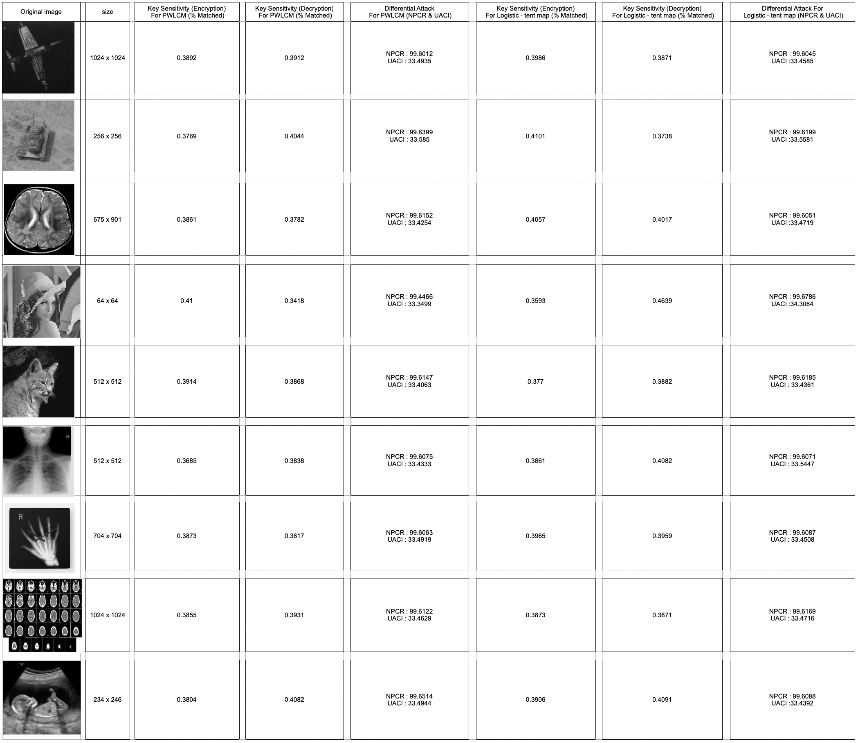

In this we see the results of both the encryption scheme with respect to the npcr,uaci and key sensitivity. From the results, we see that we obtain the 99 score on npcr and 33 score on uaci which indicates that the encryption is really good. Also, the percentage match when key senstivity is done is also less than 1%.

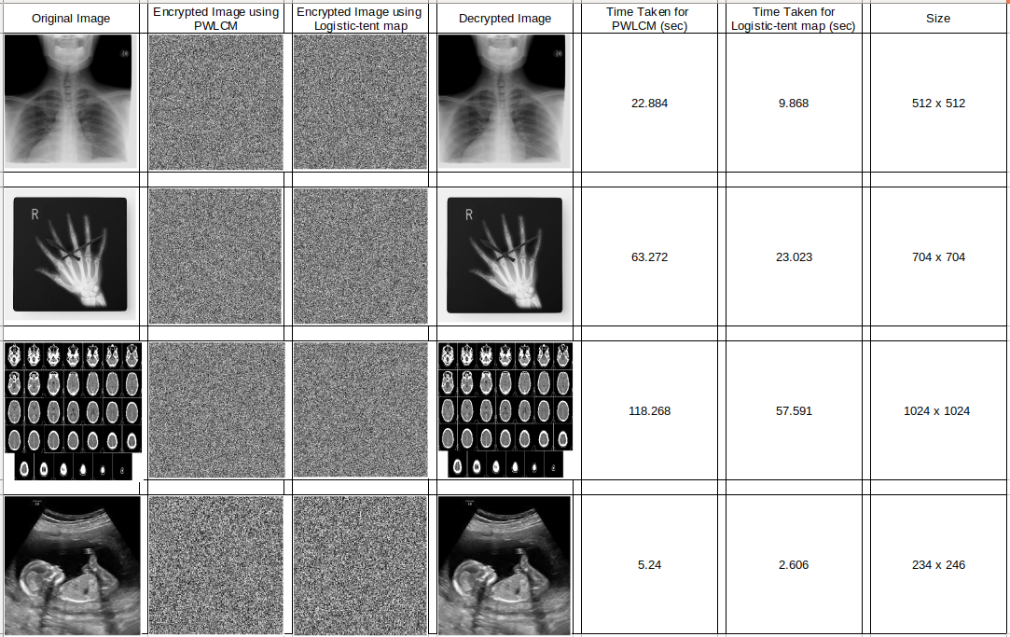

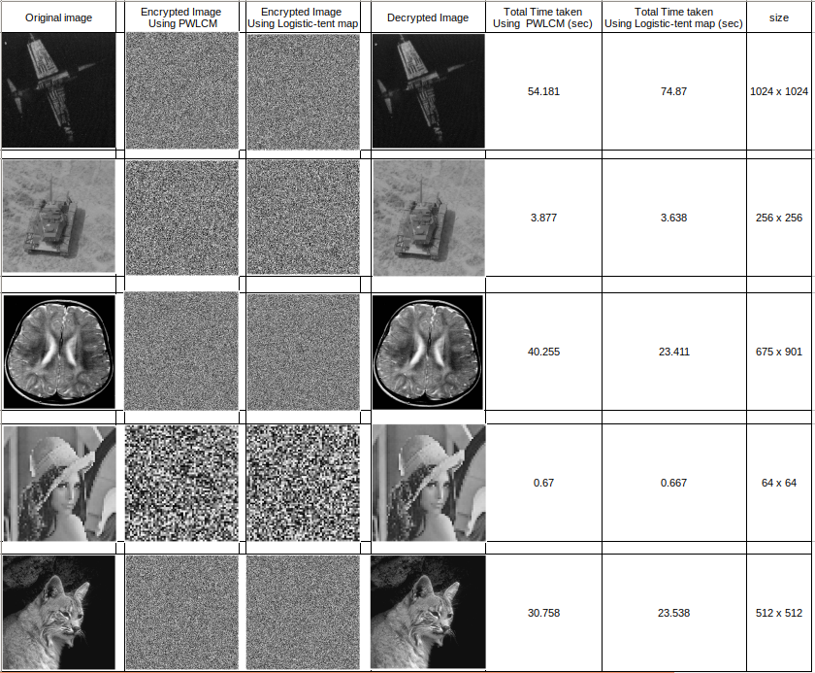

As we can see from the 2 images that as the size increases the time for end-to-end also increases. However, the encryption based on the logistic-tent seems to faster than pwlcm based encryption scheme.

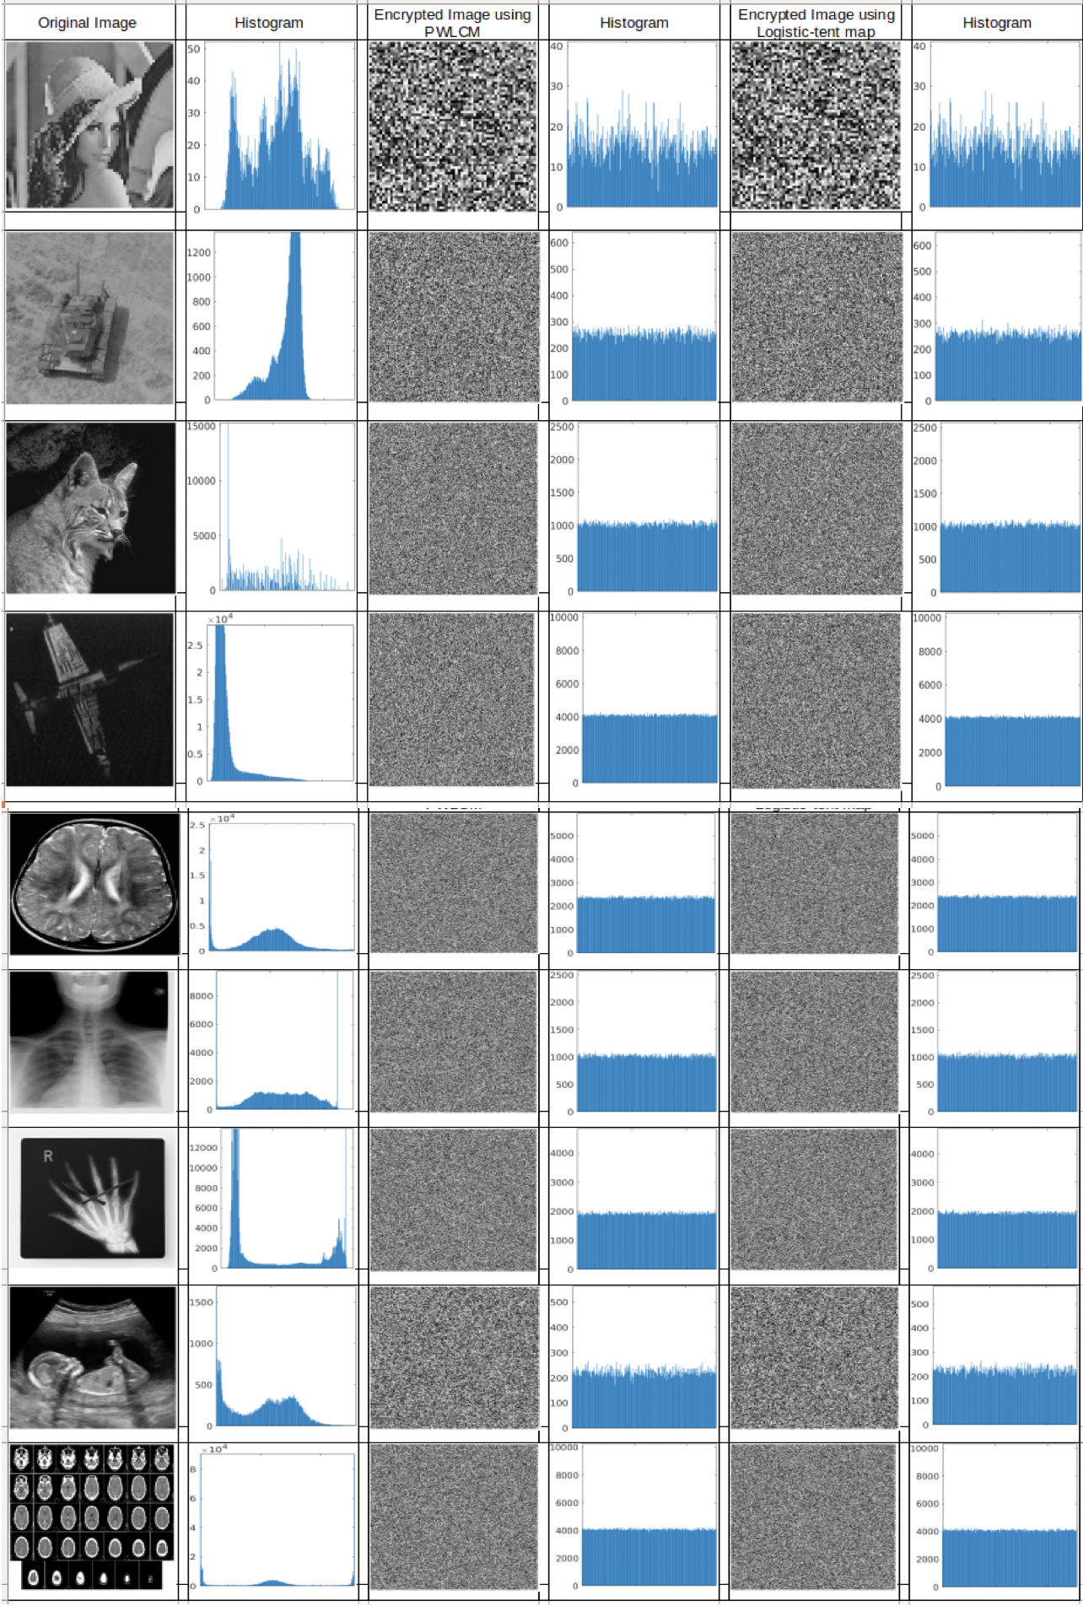

We can see that the encrypted image from both the scheme is highly uniform regardless of the intensity of the original image thus our encryption scheme is quite good.

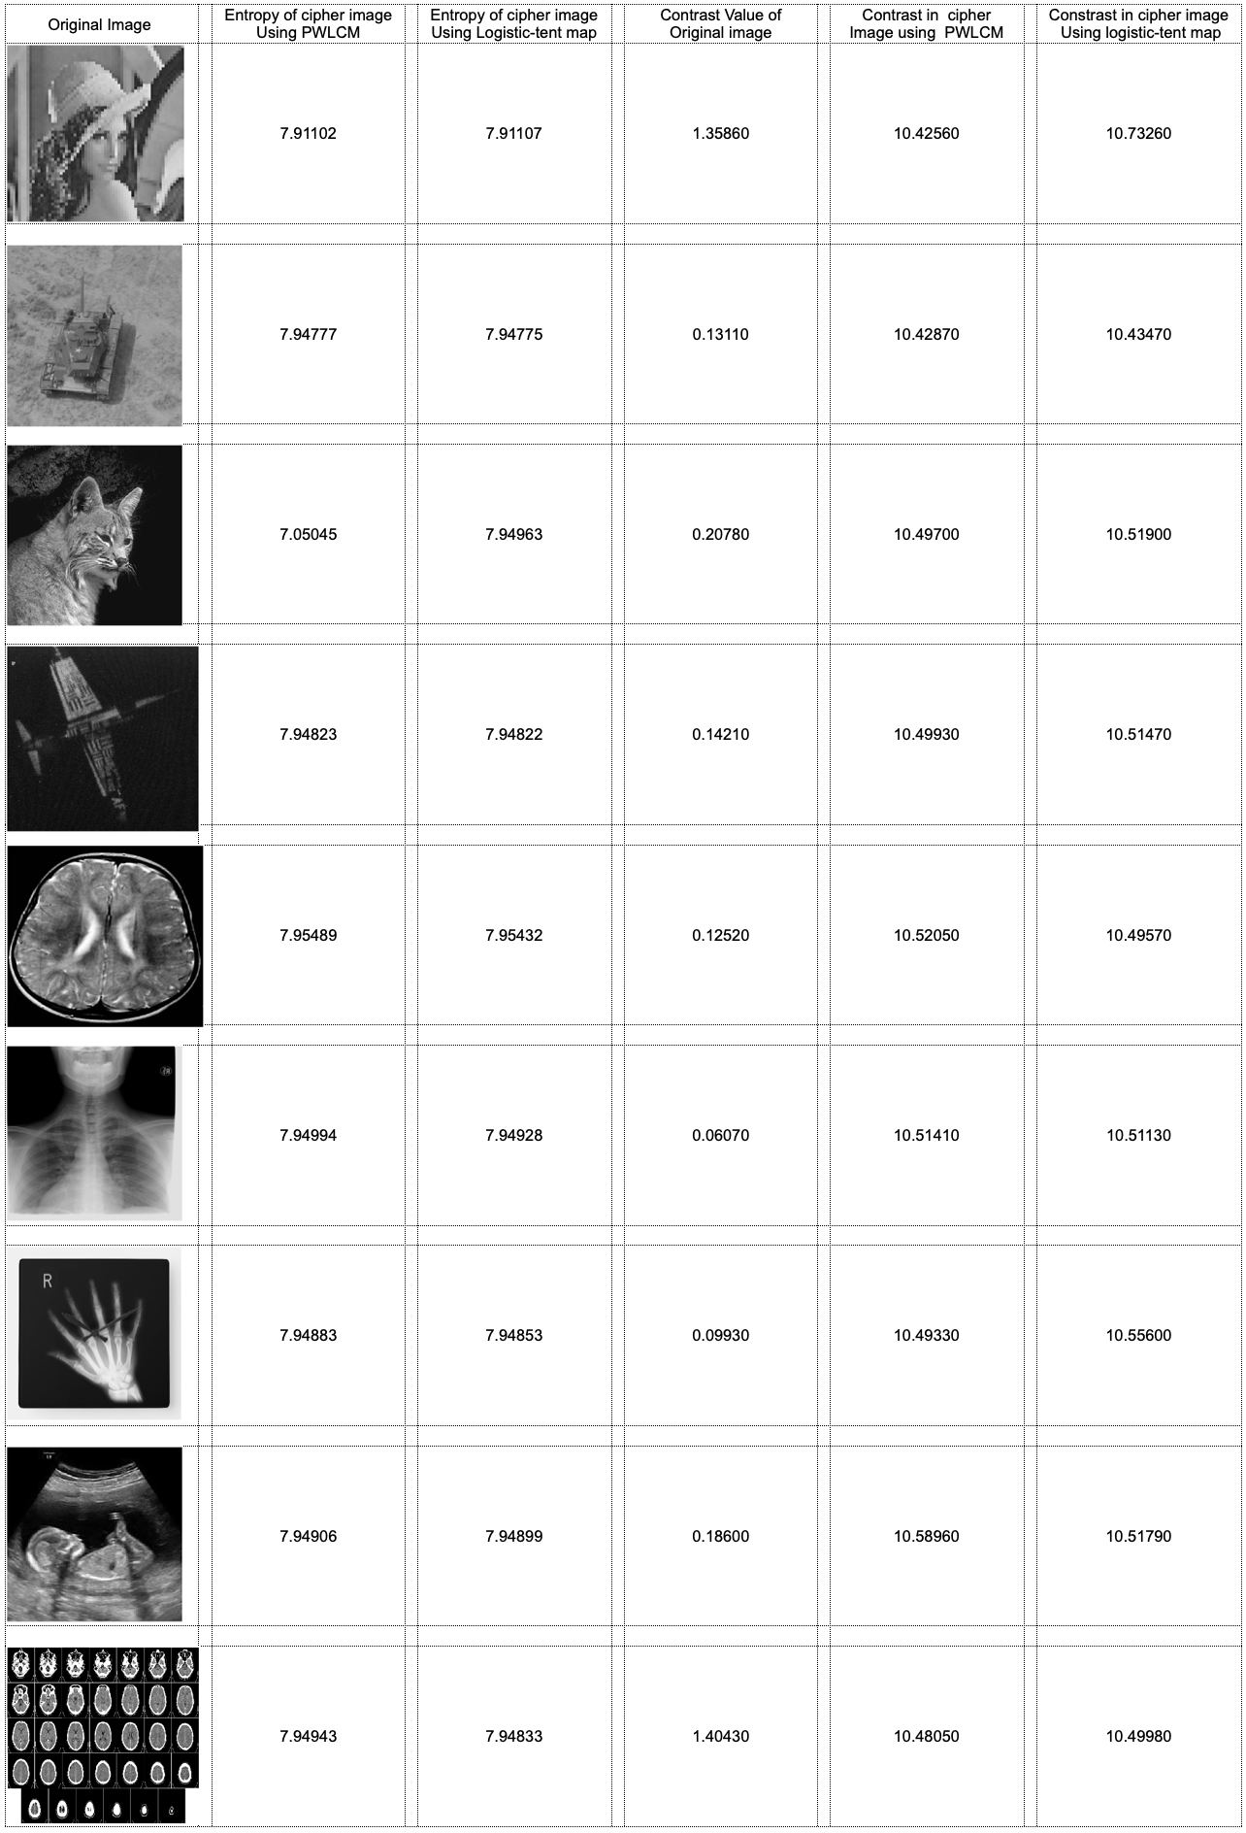

As we can see that values are closer to 8 for entropy thus the encryption scheme is good. The contrast of the encrypted image is also higher than 10 indicating that encryption works really well.

**Conclusion**

Both the encryption are implemented in matlab and tested in ubuntu system with i7 core processor and 16 gb ram. Results obtain indicate that encryption are good enough to be used for image encryption.

.-.

.